Battle at the Horseshoe Along the Saigon River
August 30, 1967

Chain of Command

25th Infantry Division “Tropic Lightning” Commanders

Major General Fillmore Mearns ……25th Infantry Division Commander
Colonel Doniphan Carter……………1st Brigade Commander
LTC. Colonel Stanley Converse ……4/9th Manchu Battalion Commander
Major Bob Sage ……………………4/9th Manchu Battalion S-3 Officer
Lt. Fritz Wiese ………………………4/9th Manchu Battalion Support Officer

269th Aviation Commanders
LTC James H. Merryman ……………Commanding Officer 269th Combat Aviation
Battalion (Black Barons)
Major John Zugschwert ………………Operations Officer (Black Barons)
LTC John H. McWhorter, Jr. …………Commanding Officer 188th AHC (Black Widows)
Major Joe Sites ………………………Flight Leader and XO for the Black Widows
Major William F. Bauman ……………Commanding Officer 187th AHC (Black Hawks)

4th Battalion 9th Infantry “Manchu” Regiment’s Company Commanders and Officers

Captain Thomas Lewman ………4/9th Alpha Company Commander
Lt. Ron Beedy …………………Alpha Company 1st Platoon Leader
Lt. McNeal ……………………Alpha Company 2nd Platoon Leader
Lt. Bill Howard ………………Alpha Company 3rd Platoon Leader
Lt. Duane Niles ………………Artillery Forward Observer attached to Alpha Co.

Captain Al Baker ………………4/9th Bravo Company Commander
Lt. Joe Wilson …………………Bravo Company Executive Officer
Lt. Jerry Nations …………...…Bravo Company 1st Platoon Leader
Lt. Craig Greaves………………Bravo Company 2nd Platoon Leader
Lt. Dave Milde………...……….Bravo Company 3rd Platoon Leader

Captain Rosenthal………………4/9th Delta Company Commander

Lt. Frankenhauser………………Delta Company Executive Officer
Lt. Rich Parris …………………Delta Company Platoon Leader
Lt. Jim Itow ……………………Delta Company Platoon Leader
Lt. Bernard Czerwinski ………Artillery Forward Observer attached to Bravo Co.

Acknowledgement

For years now (35 to be exact), Willie and I have had an immense interest in finding out more about what happened to us (the Manchus of the 4th Battalion, 9th Infantry Regiment) at the Battle at the Horseshoe, northeast of Cu Chi and south of the Iron Triangle along a U-shaped bend in the Saigon River, on August 30, 1967. Like many others, I only knew what was happening directly in front of me that day. There were surely more acts of bravery, heroism and sacrifice than we know about, but I felt we needed to record what we collectively do know. Three things became evident as we put together and wrote this article: (1) the bravery of so many Manchus, Black Hawks and Black Widows; (2) the extraordinary leadership of Captains Thomas Lewman and Al Baker; and (3) how well all of the Manchus held their ground and took the fight to the enemy.

This event couldn’t have been written about without the help and memories of those who were there. I was more of a facilitator, than an author. Much of this article had actually already been written in brief accounts and emails written by others. The most difficult thing was pulling it all together in an hour-by-hour action report in chronological order. I hope I have done this accurately, preserving that day’s events and providing a more complete picture of what happened with first-hand accounts from those who were there.

Willie Gin (Alpha 4/9 Manchu) and Dick Detra (Black Widows’ Association Historian) were a tremendous help in enabling me to pull all these facts together, as well as sharing in the writing and editing of this story. It took over a year to complete. And the collective recollections and memories (both large and small) contributed by Mark Hayes (Black Widow chopper pilot), men of the Black Windows Association, Al Baker, Ron Beedy, Craig Greaves, Melvin “Buzz” Copple, Randy “Doc” Dunphy, Nick Summerfield, Bob Castillo, Keith Bolstad, Al Clinton, Larry “Bear” Criteser, Jim Stitt, C.W. Bowman, Dave Cline, Rich Parris, Mel Shane, Bernard Czerwinski and many others made this effort possible. I’d like to acknowledge Mike Smith for finding documents from the National Archives and of course, Willie Gin and Dick Detra again for their recollections of that day.

To all of you “Guns Up!” and “Keep Up the Fire!”

Bill Fitch
4/9 Alpha Company,
Weapons Platoon
August 1967-68
2003 © Copyright

The Manchus

4th Battalion 9th Infantry Regiment; 25th Infantry Division “Tropic Lightning”

The Manchus of the 4th Battalion 9th Infantry Regiment had been in Vietnam since April 29, 1966 and were stationed in Cu Chi, and at several fire support bases (Camp Martha, Camp Juanita and Camp Caroline) near Trang Bang from April 1967 to September 1967. At the time, the Battalion consisted of one Headquarters Support Company and three Combat Companies: Alpha, Bravo and Charlie.

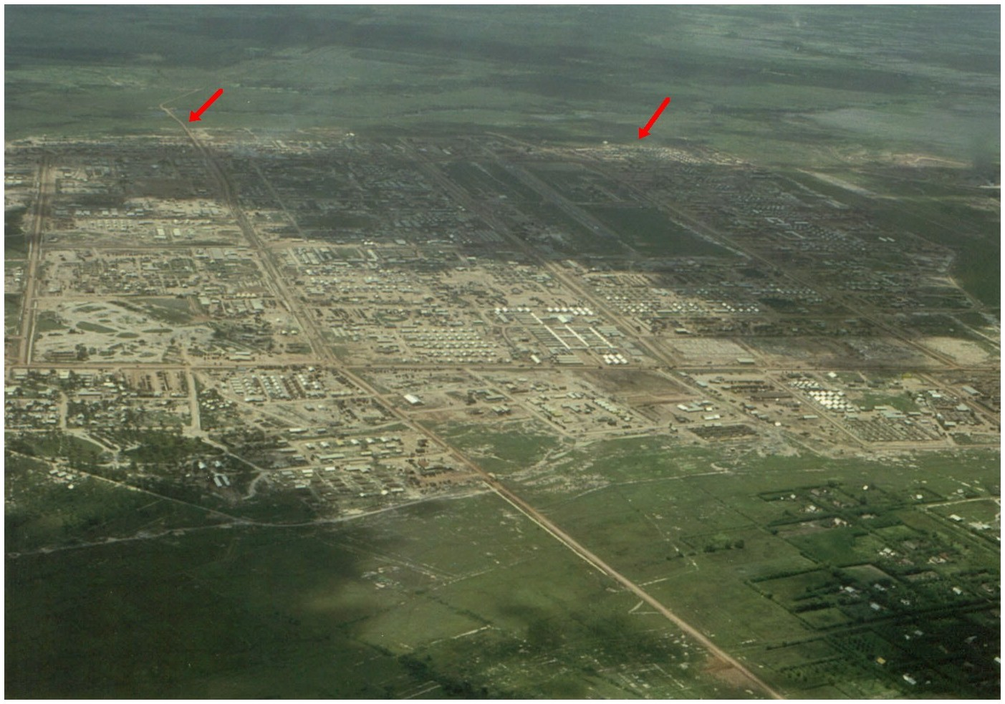

Figure 1. Mark Hayes’ photograph of the 25th Infantry Division’s main base camp at Cu Chi in 1967. The arrow on the left points to the road to Ann Margaret. The arrow on the right points toward the area assigned to the 4th Battalion 9th Infantry “Manchu” Regiment, near the airstrip, before the 1st Brigade was moved north to Tay Ninh Province (near the Cambodian border) in mid-November 1967.

During the early weeks of August 1967, it was decided that a fourth Company needed to be formed. To avoid fielding a new Company made up entirely of FNG's (Fucking New Guys), it was decided that each of the existing companies would send one platoon of seasoned men to the newly formed Delta Company—giving it a total of three platoons of combat tested veterans and one platoon of FNG’s with less than 60 days in Country. Approximately 125 new guys arrived in Vietnam aboard the USNS Barrett during the first week in August and they would provide the bulk of the new people in Alpha, Bravo, Charlie and Delta Companies. There were also some new guys pulled from Cu Chi, who arrived in Vietnam by military chartered jets, and were used to fill in the company rosters.

Approximately 36% of the Manchu Battalion had not been in heavy combat before their first battle at the Horseshoe on August 30, 1967. Before that (from August 1st through August 29th) it had been mostly routine patrols, with some sniper fire or short skirmishes with small groups of VC (Viet Cong). This new Battalion formation was not a popular move; every Company felt vulnerable after losing over 30% of their best combat-experienced NCOs and Specialist 4’s. This problem was even worse for Delta Company, since the men hadn’t worked together in any “trial by fire” missions and it wasn’t a cohesive fighting unit yet. In fact, many of Delta’s new guys had never been out in the field or faced hostile enemy fire before. This would prove to be a devastating disadvantage for Delta Company, when they were dropped into the largest and most horrific battle the Manchus had fought since their arrive in Vietnam on April 29, 1966.

The Mission

August 29, 1967
On the afternoon of August 29, 1967, Bravo Company of the 4th Battalion 9th Infantry Regiment had finished a search and destroy mission near the Saigon River and were waiting in an old rubber plantation to be taken back to Cu Chi by the 116th Assault Helicopter Company (the “Hornets”). At about the same time there was an artillery barrage going on across the Saigon River to the southwest of them. At 1600 hours, Bravo Company moved out to a dirt road (Highway 14) toward their Pick-up Zone (PZ) and immediately began receiving sniper fire from the west side of the road. When the first lift of 10 slicks (troop carrying Huey helicopters, also referred to as choppers) made their final approach into the PZ, heavy automatic weapons fire hit two of the helicopters. One helicopter made it back to Cu Chi under its own power, but the other was forced down, to make a hard landing 200 meters away from the PZ. Bravo Company's 2nd Squad (led by Sgt. Rodriguez), with the help of several gunships, rescued the downed helicopter’s crew, with no casualties. The helicopter was recovered. A CH-47 Chinook recovery team rigged the helicopter for extraction under covering gunfire from gunships capping both sides of the road with mini-gun and rocket fire.

The second lift was also met with heavy automatic weapons fire as it extracted the remainder of Bravo Company. The VC was closing in on the last of Bravo Company’s men as they tried to board the helicopters. The helicopter door gunner on the same side where Spec-4 C.W. Bowman was sitting opened up with his M60 machine gun, killing three Viet Cong who had closed to within 30 meters of the PZ.

During the same afternoon, a reconnaissance helicopter from Troop D, 3rd Squadron 4th Air Cav spotted an entrenched Viet Cong Battalion near the location where Bravo Company had made contact with the VC earlier. The search and destroy mission Bravo Company was carrying out was part of Operation Barking Sands. No one knew it at the time, but this area of the Iron Triangle contained a vast underground tunnel complex running in a north-south direction. The tunnel complex was so large that it took three days and nights to walk and crawl from one end to the other. The Viet Cong were spotted in a Horseshoe-shaped area on the Saigon River, eight miles northwest of Phu Cuong. The Air Scouts (Centaur) from Troop D had found a large concentration of VC, believed to be the battle-hardened 2nd Go Mon Battalion, dug in along a U-shaped bend in the river at a point where the Thi Tinh River merges with the Saigon River. Major General Mearns decided to use Korean War tactics on the concealed VC: heavy pre-strikes, followed by sending infantry into the area. More than 5,000 rounds of air and artillery ordnance would be used to pound the area before the Manchus’ arrival.

The problem with this tactic of “prepping” an area with air strikes and artillery shelling is that it works fine on an enemy that does not have heavily fortified bunkers and are not well-disciplined soldiers. But when used in Vietnam, it told the VC exactly where the Landing Zone (LZ) was and where our helicopters were going to drop our men. In addition, the 25th Divisional Command’s decision to drop Chieu Hoi leaflets into the area did not help matters. This was done in an attempt to get the VC to surrender or defect. These tactics were especially ineffective with the Go Mon Battalion, who was well disciplined, highly trained, and heavily armed. Perhaps most ominous of all, the Go Mon had constructed heavily fortified bunkers in a 7-point ambush inside the Horseshoe-shaped area, which was bordered on three sides by the Saigon River.

The following day (August 30th) the Manchus were about to test the battle worthiness of the Go Mon’s fighting positions: (a) the enemy would ambushed Alpha Company’s LZ from a complex of 20 fighting bunkers with two escape routes each, and on their right flank were open fighting holes; (b) Bravo Company’s LZ would be defended by an enemy complex consisting of 2 large bunkers (6' x 8' x 8'), 2 smaller bunkers, 4 two-man fighting foxholes, a reinforced bunker hut with a tin roof, 12 spider holes dug into a canal line, and a half completed command bunker; and (c) the enemy would attack Delta Company from a 12' x 7' concrete-walled bunker extending four feet above the ground (with 2-inch steel beams supporting the roof), 3 large fighting bunkers (9' x 5' x 4'), 1 large command bunker (14' x 5' x 4') and 15 spiders holes spaced fifteen meters apart. The Manchus were about to be unwittingly dropped into the middle of Hell.

August 30, 1967
On August 30, 1967, the Manchus were enjoying a rare stand-down in Cu Chi. They were being held in reserve for some Divisional Base Camp R&R (rest and recuperation).

In the predawn hours of August 30th, the Manchu Company Commanders were summoned to the Battalion Tactical Operations Center and issued orders to conduct an air assault. They were told they were going to a place northeast of Cu Chi in Binh Duong Province—8 miles northwest of Phu Cuong, and about the same distance south of Ben Cat—at the most southern edges of the Iron Triangle in a “Horseshoe-shaped area” along the Saigon River, where the Saigon and Thi Tinh River meet.

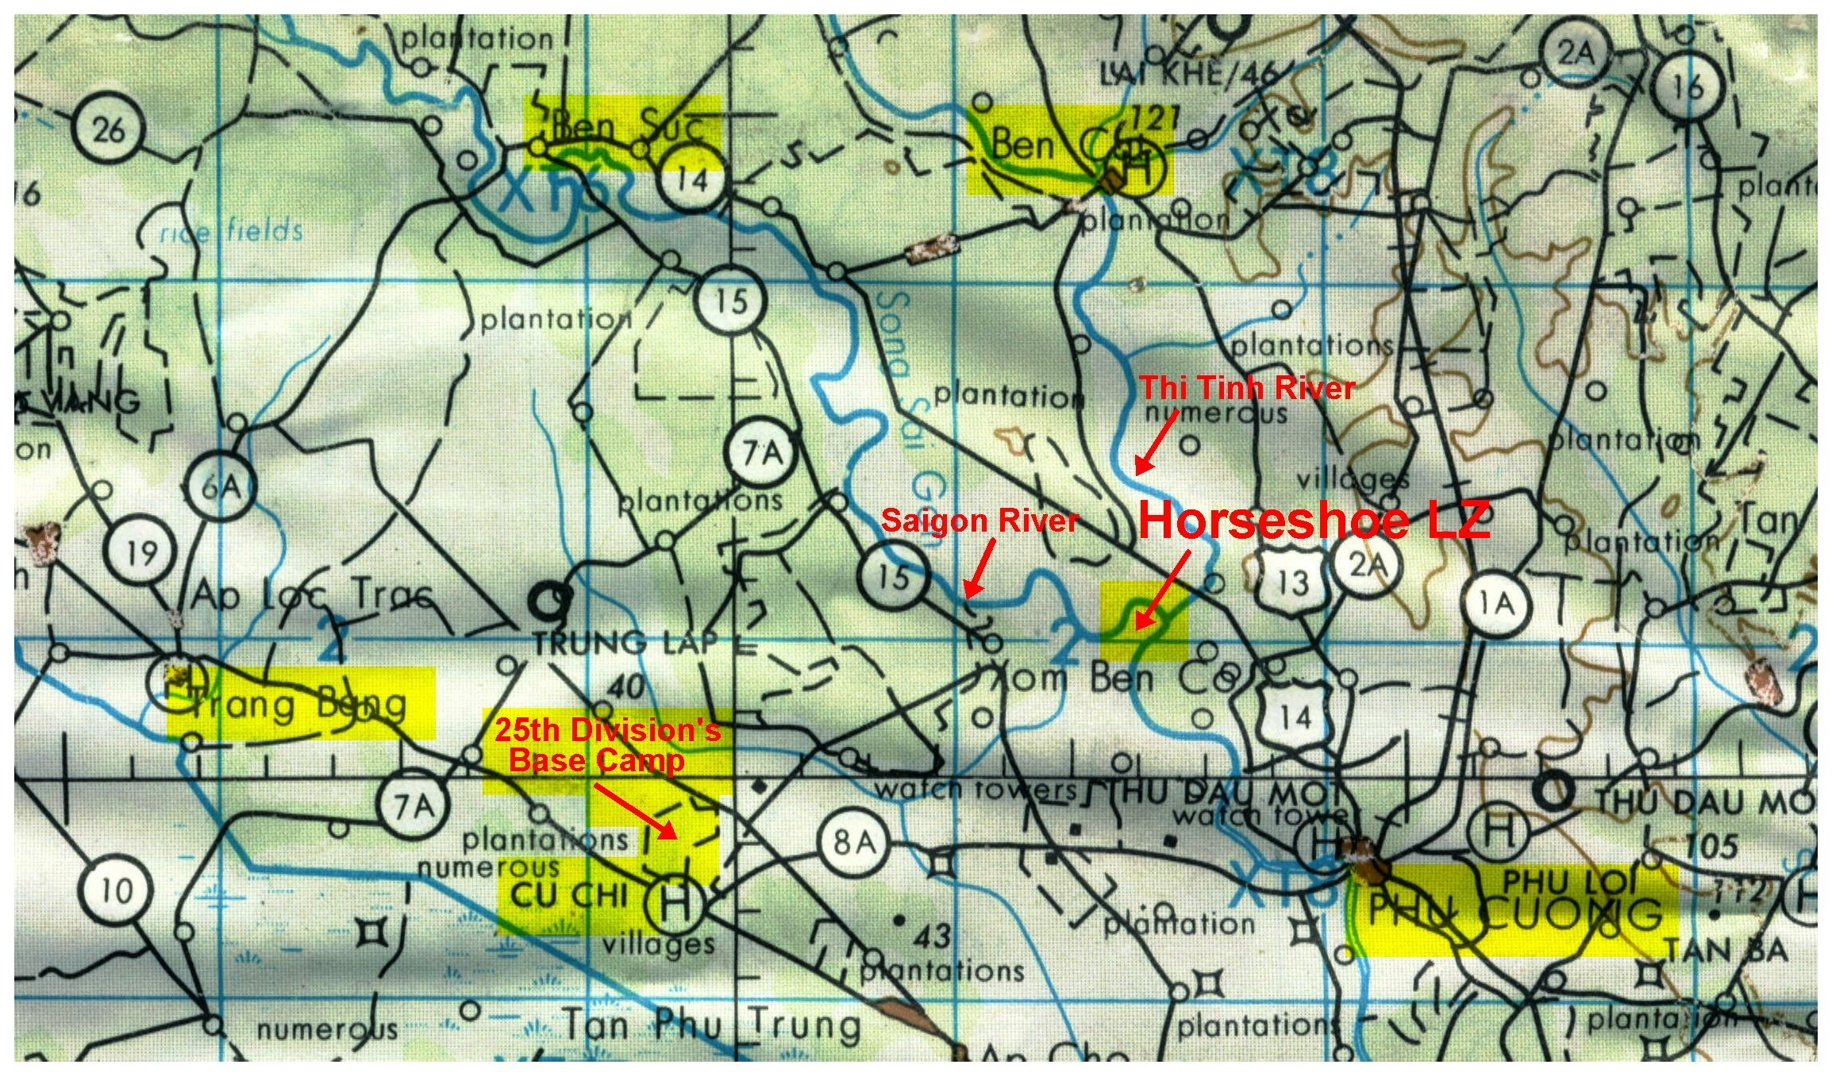

Figure 2. Section of an E & E Map showing the boundary of the Iron Triangle and the location of the Horseshoe-shaped bend in the Saigon River, northeast of the 25th Infantry Division’s main base camp near Cu Chi.

The surrounding area was a hellish place of danger and death, containing hardcore Viet Cong soldiers. If any place in Viet Nam could be called the frontline, it would be the Iron Triangle. This was the enemy’s territory, and there were no areas within that could be called safe. The Iron Triangle was a no-man’s land and a free fire zone. Anything that moved was considered Viet Cong and a legitimate target for destruction. Historically, the Iron Triangle was a 60 square mile area, bounded by the Saigon River to the south, the Thi Tinh River to the east, and to the north by a line running west from the town of Ben Cat to Ben Suc, incorporating the Thanh Dien Forest Reserve to the north. This area was a heavily fortified Viet Cong sanctuary known to contain VC Headquarters for Military Region IV, which directed military, political and terrorist activities in the Saigon-Gia Dinh Region (approximately 13 miles away). VC control of the Iron Triangle permitted their forces to dominate key transportation routes in the surrounding area, as well as controlling and supporting their operations.

More about the Iron Triangle: During Operation Cedar Falls (January 1967), Military Intelligence suspected VC units in the area were the 1st and 7th Battalions of the 165th Viet Cong Regiment, the Phu Loi Local Force Battalion and three other local force companies. Other intelligence sources indicated that the 2nd, 3rd and 8th Battalions of the 165th VC Regiment might be in the area as well. Operation Cedar Falls’ mission was to attack the Iron Triangle and Thanh Dien Forest Reserve, destroying the enemy forces, infrastructure, installations and Military IV Headquarters. The civilian population was evacuated to establish the Iron Triangle as a Free-Fire Zone to preclude the area's further use as a support base for Viet Cong operations. This was a joint operation conducted by the 1st and 25th Infantry Divisions and the 11th Armored Cavalry Regiment. The spoils of the operation were 720 known enemy casualties, 576 ralliers, 3,294 tons of rice, 429 small arms, 18 crew served weapons, large caches of ammunition and sampans. The Manchus didn’t participate in Operation Cedar Falls.

Combat Assault Plan
This was to be a “hurry-up and go” operation. Division command was confident that most of the Viet Cong Battalion had been decimated by the heavy air and artillery strikes. The Manchu company commanders were told that this was going to be a short 2 to 4 hour operation to do a Bomb Damage Assessment and count the number of dead VC. They were told that a few VC might have survived, and that they might have to mop up some pockets of enemy soldiers. The Manchus were instructed to prepare for a quick “in-and-out” mission, making it unnecessary to carry C-rations, ponchos, night kits or additional ammunition—in other words “travel light”.

The 188th Assault Helicopter Company (the Black Widows, based at Dau Tieng) and the 187th Assault Helicopter Company (the Black Hawks, based at Tay Ninh) would be inserting the Manchus into the Horseshoe. Each company would commit one lift of ten slicks, one spare and one maintenance helicopter. In addition to providing the transport helicopters, both AHC companies committed two Light Fire Teams to the mission. Each team was made up of two gunships, totaling eight (four each from the 188th Spiders and the 187th Rat Pack gunship platoons).

The aerial Combat Assault would consist of two lift companies, totaling 20 slicks, escorted by four gunships. The remaining four gunships would be on standby, rotating with the other gunships when returning to Cu Chi to refuel and re-arm. The air assault plan was to take Alpha Company in as the leading element (the first insertion), landing them first in the north sector of the Horseshoe; followed immediately by Bravo (the second insertion) who would land in the south sector. Delta Company (the third insertion) would come into their LZ later, after the two lift companies returned to the PZ to pick them up, and land further south of Bravo Company.

The first two insertions would require the use of two lift companies. Two gunships would escort each insertion to their landing zone, capping the LZ with machine gun and rocket fire while leading the way in. When the slicks were on the ground at Cu Chi, four gunships would remain circling the LZ providing fire support. Charlie Company would stand down and be held in reserve in Cu Chi, because Divisional Command thought that three infantry companies would be more than adequate for a routine mission. The last days of August 1967 would become a dark chapter in the history of the Manchus, Black Widows and the Black Hawks.

The Enemy (Go Mon Battalion)

It has been said that Military Intelligence is a contradiction in terms; this was certainly the case on August 30, 1967. Military Intelligence didn’t know anything about the Go Mon Battalion other than its name and that the 3rd Squadron 4th Air Cav had located them along the Saigon River. The Manchus would fight other battles with this VC Battalion and would learn more about them as 1967-1968 went by. If Military Intelligence had told us more about whom we were fighting, I am sure we would have been better prepared and our KIA (Killed in Action) and WIA (Wounded in Action) casualties would not have been as high.

This is what we found out later about the Go Mon Battalion. The Battalion was named for its leader and was formed in the 1950’s to fight the French during the French-Indochina War. This was an elite combat unit along the lines of our US Army Rangers. Their area of operations was from the Ho Bo Woods to the Iron Triangle. They were a cohesive hardcore military unit that had been together for a long time. Their Battalion and Company Commanders were the best VC officers in the region. They were a specially trained unit that received their military training in Hanoi. They had been issued modified AK47’s with folding fiberglass stocks. The Go Mon had specially trained sniper teams using mounted scopes on their weapons. They had excellent fire discipline, firing only when they were sure they could hit their target. They were trained to go for a headshot—not to fire wildly or rapidly at just anything that moved—and to fire only a few controlled rounds at a time.

The Go Mon made the local population prepare fighting bunkers for them and held family members hostage to make certain no one gave information to the US Army. They were experts at designing heavily camouflaged fighting positions. They built their positions in-depth so that they could fight both forward or backward with a way of escaping nearby. If supporting fire (artillery strikes) were brought to bear on their front positions, they could fall back to their second or third lines of defense. If the artillery was readjusted to their fallback fighting bunkers or holes, they could move forward again to their frontline positions and take on their adversaries with close-in fighting. They took great care to remove their dead when retreating so that their true casualties and presence in an area would not be easily known. The Go Mon never fought without an escape plan by shallow water sampans, hidden tunnels or paths. The Manchus, 33% green soldiers, were about to face one of the best enemy battalions in Vietnam. The Go Mon would outnumber us. As if this was not bad enough, one of the three Manchu Company’s (Delta Company) was still a new-thrown together Company, not yet a cohesive fighting unit.

Approaching the Landing Zone

At 0830 hours, air strike support for the day’s operation resumed prepping the area of operation with bombs, stopping at 0908 hours. A few minutes later, at 0910 hours, a massive barrage of artillery fire pounded the area in preparation for the Manchus’ combat assault.

At 0917 hours, the Black Hawks and Black Widows approached the Horseshoe with 20 slicks, escorted by four gunships, and at approximately 0924 hours, went into a circular holding pattern while the artillery strike dropped their remaining ordnance on the area. By then it was riddled with bomb craters; many of which were filled with water, giving the appearance of numerous one-acre ponds scattered throughout the operational area. WO Mark Hayes (Black Widow 14, chopper pilot), who was in the middle of Bravo Company’s lift of helicopters made the remark going in on the initial approach into the Horseshoe, "The LZ appears to have been prepped with everything short of an Arc Light (B-52 bombers)…."

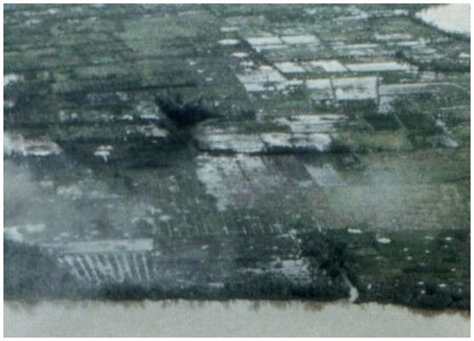

Figure 3. Mark Hayes took this photograph, shortly before entering the Horseshoe on an emergency TAC-E resupply and evacuation mission, while an air strike dropped its ordnance into an area of contact. Pictured is a 750-pound bomb explosion. The photograph was taken from the north, looking toward the south. The left side of this photograph is east and the right side is west.

The entire area was an infantrymen's worst nightmare. The LZ was open water rice paddies with low dikes running parallel and at right angles to each other. The most sinister features were the heavily wooded areas, tree-lined embankments, narrow canals, stream inlets and bamboo thickets around the LZ. Upon seeing Alpha's LZ for the first time, Lt. Ron Beedy said, “My God, we’re not going in there are we?”

Alpha Company’s LZ Insertion
At 0933 hours the Black Hawks (with ten 10 slicks) entered the Horseshoe in a Trail Formation, with Alpha Company’s Command Group in the lead. Both flights [Alpha and Bravo’s] entered the Horseshoe from the northeast and proceeded toward the southwest toward their assigned landing zone. There was no incoming fire as the first lift of choppers made their final approach—slipping past forested areas surrounded by expanses of water-filled rice paddies. As the landing zone came into focus one could clearly see scores of wooded areas, creek inlets, canals, overgrown embankments and hedgerows scattered throughout the Horseshoe. As the Black Hawks approached Alpha Company’s LZ (at the northern sector of the Horseshoe), their initial drop was made beside the Northeast corner of a large rectangular shaped forested area, with diked rice paddies filled with water along its northern and eastern sides. Separating the tree-lined embankments of this heavily forested area, from the first dike directly in front of both [north and east] sides of the Northeast corner, was a water-filled rice field—approximately 30 to 40 meters wide—creating the appearance of a moat wrapping around the corner of a protected fortress, with an open field of fire on both sides of it.

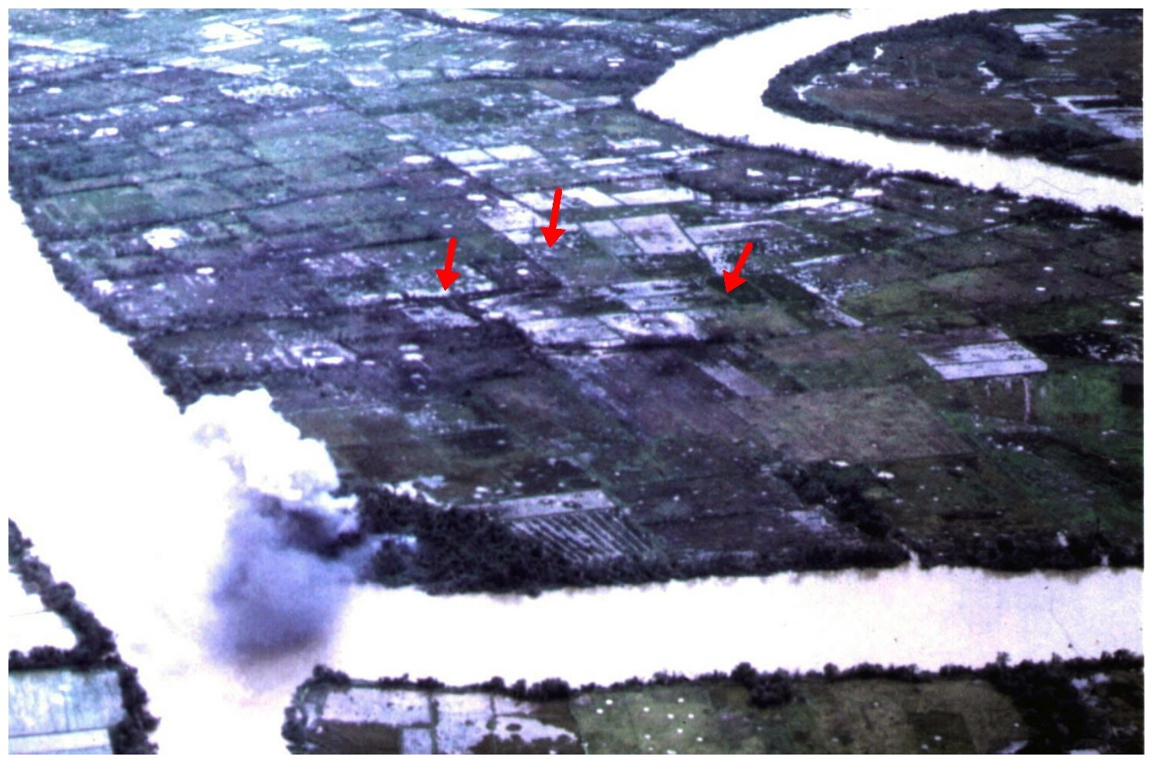

Figure 4. This photograph was taken from the northeast corner of the Horseshoe, looking toward the southwest. Pictured at the lower-left corner of this photograph are two large clouds of smoke coming from a brush fire; a jet had just dropped napalm bombs on the northeast corner of the Horseshoe.

Right-Arrow: Pointing at Alpha Company’s Landing Zone, alongside of a large rectangular shaped forested area. Center-Arrow: Pointing to the general vicinity of Bravo Company’s Landing Zone. Left-Arrow: Pointing at a location along a tree-lined finger stream, where a side-canal branches off to the north. At the spot where this arrow is pointing, Captain Al Baker’s sniper knocked out a VC bunker.

Meanwhile, back in Cu Chi, Lt. Rich Parris was listening intently to the radio. The initial reports were “LZ Cold” and everyone breathed a huge sigh of relief. However, this report was short lived. Within seconds, the radio waves were alive with numerous calls of “LZ Hot!” "LZ Hot!” Then the screams over the radio took on a terrifying tone, as “Chopper Hit!” “Chopper Hit!” began filling the airways. The Go Mon Battalion waited patiently until Alpha Company's choppers started unloading their men. Then springing their ambush—opening up with everything they had. The battle at the Horseshoe had begun.

The Go Mon Battalion’s strategy quickly became apparent. It was to hold their fire until the landing zone was full of choppers unloading the bulk of Alpha Company's men, and then firing at the choppers and their disembarking infantrymen simultaneously. It’s at this moment when the chopper and their men are the most vulnerable. The chopper is at a stop and still in a hovering position and men are jumping off with no protective terrain features to take cover behind.

The first group of five Black Hawk choppers carried Alpha’s Command Group (consisting of Captain Thomas Lewman, RTO Spec-4 Nick Summerfield, and Alpha's forward artillery observer, Lt. Duane Niles), as well as elements of the 1st and 2nd Platoons. The Command Group was known by the call sign “Alpha-6”. On this particular day, Captain Lewman was wearing silver captain bars instead of the blacked out-insignia patches. This caused Nick Summerfield some distress—feeling that he with the radio and Captain Lewman with his shiny silver bars would be too conspicuous if the lead started flying. As Captain Lewman and the rest of the Alpha-6 party landed, he tried to check the terrain to decide which way to go. Captain Lewman made a quick decision that the mission’s objective was away from the wood line. The Command Group started moving to the east of the LZ. Suddenly sporadic enemy small arms fire erupted from the wood line that Alpha-6 was about to leave. Captain Lewman quickly ordered an about-face and moved back toward the wood line to engage the enemy. Alpha-6 took up a position behind the first rice paddy dike that was directly in front of the east wood line. This dike was 30 to 40 meters from the wood line and an open rice paddy filled with water separated the dike from the tree-lined embankment. As more choppers started coming toward the LZ, the enemy began concentrating their gunfire and mortars on the incoming choppers. Immediately the helicopter pilots started reporting that they were in a hot LZ and taking hits from intense automatic gunfire.

The rest of Alpha Company’s flight (carrying men from the 2nd and 3rd Platoons and one squad from Weapons) was now coming under intense gunfire on their way toward the landing zone. Enemy tracer rounds were streaking toward the choppers, through the flight formation, and hitting the choppers and some of the men onboard. Many of Alpha Company’s men were becoming casualties as they jumped from the choppers. As Lt. Bill Howard and his RTO disembarked their chopper, they made a dash for a dike in front of the wood line for protection. A burst of machine gun fire barely missed Lt. Howard, but his RTO caught the full force of the blast.

The rice paddy LZ was a deadly mixture of quicksand-like mud lying beneath the surface in knee-to-waist-high water. This made moving quickly impossible, and the VC took full advantage of the slow moving targets. However, bringing down a chopper was the VC’s primary objective—getting them while they were approaching and hovering above the ground; at their most vulnerable. So for a few brief seconds, most of the enemy gunfire was directed at the choppers. These precious seconds barely gave Alpha Company's men enough time to find cover. If the Go Mon had concentrated all of their firepower on Alpha Company’s men during the first lift’s initial landing, the casualties would have been horrific. Lt. Ron Beedy said many of the men were hit during the first few seconds on the LZ. The Command Group, and parts of the 1st and 2nd Platoon, had managed to make it to the first dike, and the rest of the Alpha Company was scattered and pinned down all across the LZ, out in the open water-filled fields. Later in the day, SFC Charles R. Wilkerson was found dead quite a distance away in a large rice field.

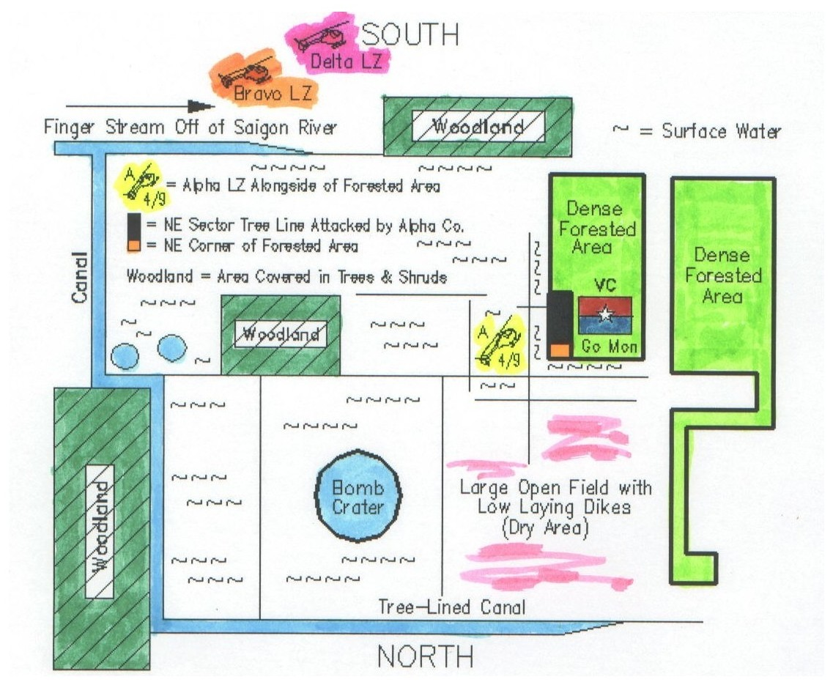

Figure 5. Diagram of Alpha Company’s Land Zone (LZ), alongside the Northeast sector of a large rectangular shaped forested area. From inside of this dense forest area, the Viet Cong ambushed Alpha Company’s landing from well-camouflaged bunkers and open fighting holes hidden along the tree line—trapping Alpha’s men out in the open rice paddies. Later in the day, after calling in artillery and air strikes, Alpha Company’s men counterattacked this section of the woods by moving away from the protection of the dikes and charging across a water-filled rice paddy in an attempt to break up the Viet Cong’s relentless attack.

Bravo Company’s LZ was located southeast of Alpha’s position, in an area south of a tree-lined finger stream branching off of the Saigon River. Where this stream intersects with a canal, Bravo Company’s sniper knocked out a VC occupied bunker—opening up two waterways and allowing Captain Baker to get a platoon into the east sector of the stream.

Approximately 30 minutes after Bravo’s LZ landing, Delta Company’s flight started landing in the same vicinity as Bravo’s LZ.

Willie Gin's description of his initial approach into Alpha Company's LZ is typical of what Bravo and Delta Company would experience on their approach into this Hellhole:

“The initial approach to Alpha's LZ was nothing out of the ordinary. The door gunners closest to the wooded areas began putting M60 machine gun fire into the tree line as they passed by them, with their passengers doing the same. Everything appeared normal; a routine maneuver. As we got closer to the landing zone and lower to the ground, the scene quickly changed; looking entirely different from what most of us had previously seen or experienced.

As the lead slicks slipped past the Northeast corner of the forested area in trail formation, explosions suddenly started going off to the front and sides of the slicks, mixed with automatic gunfire coming out of the woods on the right side of the formation. Long lines of green tracer rounds from the enemy's automatic gunfire came zipping through the formation, hitting their intended targets. Immediately the other incoming slicks began breaking formation. Some of them veered off to the left of the leading slicks that were still hovering above the ground dropping off their troops. Others went seeking safer spots nearby, while still others came straight into the hot LZ replacing slicks that had just flown off after disposing of their troops. The rest of Alpha Company was being helplessly scattered throughout the area.

In the midst of this ambush, while our slick was still hovering 4 to 6 feet above the ground, the aircraft pilots started yelling, "Get out of the fuck'n chopper! Hot LZ! Hurry-up, get out! Jump!" while maintaining hovering speed—and set to take off quickly in fear of being shot down by the incoming gunfire, or worse yet a mortar round or rocket grenade (RPG) that would send all aboard to their deaths. The aircraft pilot was not about to land, so we followed the crew's command, dropping out of both doorways into a muddy paddy, up to our knees and waists in deep muddy water infested with leeches.

Most of us had fallen so deep into this mud-hole that we had difficulty working our legs and ankles free. This drastically impeded our attempt to get quickly behind a small dike for protection from the enemy's gunfire. Even the slick's powerful rotor blades hindered our attempt—whipping up strong gusts of swirling wind, combined with muddy water and debris picked-up and lifted into a swirling wind tunnel, capable of blowing you over. It was tough enough trying to keep your balance in water-filled paddies, much less standing up and fighting that powerful force. A force that stung open eyes and brought out tears, while simultaneously slapping you in the face and hitting the sides of your body—throwing you off balance, making it harder to see where you were going and what was happening around you. All this time we were under attack; stuck in the mud like sitting ducks, water exploding upward in plumes from gunfire impacting the water's surface, and desperately trying to work our way to safety so we could engage the enemy.”

Lt. Ron Beedy, Alpha Company 1st Platoon leader landed with the first group of slicks and had also gotten stuck in the mud and was struggling to make his way to a dike for cover. During those first few minutes he had no awareness of the whereabouts of anyone else, except for his RTO Peter (Rabbit) Gaviglia who was right beside him. Beedy’s Platoon was scattered across the LZ, with some of his men pinned down by heavy fire and unable to maneuver. He had a small group of men with him, but could not take the chance of standing up to look for the rest of them. Beedy said, “We were pinned down for hours by small arms fire coming from a tree line of thick bamboo growing along [what appeared to be] a canal leading into the Saigon River.”

When Staff Sgt. Sanford C. Schultz and Spec-4 Randy “Doc” Dunphy jumped from their chopper, there were only a few other choppers ahead of them. The two of them landed in the muddy-bottomed rice paddy, bogged down almost up to their waists in water—and Doc Dunphy could hardly move. As their chopper headed off, Dunphy heard someone cry “Medic!” and started moving as quickly as he could toward the sound. Dunphy was twenty feet to the left of Sgt. Schultz, who was moving surprisingly fast through the mud and water, yelling at him to get going. As Schultz quickly moved forward, Dunphy began to lose ground and fall behind. Dunphy remembers Schultz turning back to him and screaming, “Damm it Doc, move your ass or I’ll put a bullet in you myself!” After moving several more meters toward the cries for help, Dunphy reached Spec-4 Terry Craft and another Manchu. Shedding his heavy flak jacket, web-gear, steel pot and rifle, he asked them to keep his gear for him and started moving forward again. Finally, Dunphy reached Lt. McNeal, who was being treated by Larry “Doc” Fulks. Shortly afterward, Doc Dunphy heard several other calls for a medic and again headed off toward the sounds for the help.

Lt. Beedy was just half a rice paddy away when Lt. McNeal was wounded. He saw him standing up and yelling for a medic to help a fellow Manchu who was wounded during the LZ landing; then McNeal was promptly shot in the thigh. With McNeal out of action, Sgt. Schultz took command of the 2nd Platoon. At some point, a bullet hit Schultz’s rifle as he held it in front of him, knocking him backward. His weapon had undoubtedly saved his life.

PFC Willie Gin and two Alpha FNG's were finally able to stop a moment to catch their breath after getting to safety. Peeking over a dike they were able to observe what was happening in the area around them. Incoming choppers were still dropping off troops, and groups of soldiers were forming up along the very first dike in front of the tree line and firing into it. They could see Alpha’s Command Group there with them. Separating that first dike from the tree-lined embankment was a long water-filled rice paddy 30 to 40 meters wide. This was the place where Alpha Company's first lift was receiving most of the enemy gunfire from, the east side of a large rectangular forested area.

“We (the three of us) had worked our way to another dike north of the Command Group. This dike ran along the north side of the forest. 30 to 40 meters in front of it, there was also a rice paddy between it and the tree line as if it were a moat, with the corner of the forest as its fortress. In short order, a Sergeant was yelling over to us to move out—pointing toward the corner where the two dikes intersected.” Willie Gin and two others started running down the dike, past the Northeast corner to the other side.

When they were no more than 25 meters past the Northeast corner, the two Manchus running in front of Willie were hit by a quick burst of enemy fire. The guy in the lead fell to the right side of the dike into the water and the guy behind him fell to the left, exposing himself to further enemy fire. Willie was able to reach over the top of the dike and pull him over to safety, and quickly attended to the bullet wound in the side of his waist. As soon as Willie had him bandaged up, he went to the aid of the other PFC who was slightly wounded and lying alongside the dike, with his head leaning against it and his body submerged below the surface of the water.

It was then that Willie saw another wounded Manchu, who turned out to be Alpha Company's 1st Platoon medic, Daniel "Doc" Zogg. Doc Zogg was lying stranded out in the open exposed to the enemy fire, in the water-filled rice paddy. He had made it a third of the way toward the Northeast corner of the tree line when he was hit. At the time, Willie and his two WIA's were the only people behind their dike, with no one else close by. Zogg appeared to desperately need help and could not move, so Willie reluctantly disposed of his weapon and went after him. Willie went up, over the dike, and away from the protection it offered. He crawled slowly toward him, keeping his body as low and far below the surface of the water as possible. Zogg said he had been hit around his inter-thigh-groin area. Willie dragged him through the shallow muddy water up to the edge of the dike, and tried to lift and push him over the top. He was too big and heavy, and after several failed attempts, Willie stopped trying. Willie was now exhausted and these attempts had been painful for Zogg. Leaving him was not an option, so Willie took a bandage out of the medical bag and tried to put it around his wound. Due to the mud and water, Willie could not see the wound to bandage it. Finally, several others arrived and helped pull Zogg to safety behind the dike. Willie then took some bandages from Zogg’s medical bag and left him in the care of the others. Looking back on this incident, Willie considers it a miracle that he and Doc Zogg were not killed. Either the VC were preoccupied with other parts of the LZ or Alpha Company had begun to lay down some effective suppressing fire into the wood line that made their escape from the open paddy possible.

As he left Doc, Willie noticed several guys yelling and frantically beckoning him to come to them in the next field. This was the first time he had seen any sizable group of soldiers. Willie headed off in their direction and discovered they were in a dry grassy field, hunkered down behind a dike and in several depressions in the ground. At the time, he recognized none of them and thought they were from another platoon or even another Company. Thinking he was a medic, they asked Willie to help with a wounded man. A blood-soaked bandage was placed loosely over the top of the guy’s stomach wound. Willie lifted the bandage up and saw that a gunshot had opened up the fatty tissue of the man’s stomach and you could see some of his intestines protruding. Willie was not a medic but did what he could. He wrapped several clean bandages securely around the wound to slow the bleeding.

Willie felt as though he had done enough medic work and the wounded were being taken care of, so he headed off to find his platoon. Not wanting to get any closer to the wood line, he headed off in an outward-circular direction toward the east and doubled back toward the front of the woods. Willie could see Alpha Company in front of the northeast sector of the tree line, exchanging heavy gunfire with the VC. Up to this point, he had not fired his weapon. Finally, three or four paddy fields from the woods, he came across someone he recognized: Randy Dunphy, 2nd Platoon's medic. Happy to see Doc Dunphy, he put his hand on his shoulder to get his attention because he was lying real still, flat on his stomach. Willie was beginning to wonder, "Is he shot, is he dead, or what?" As Willie rolled him over, Dunphy said, "I just got shot in the back!" After examining him, Willie could see where a bullet had gone through the back of his jungle shirt, but did not cause a wound. Dunphy had been badly shaken by this near miss, and after Willie told him he was not wounded, he quickly got moving again to help with the wounded. Dunphy spent the rest of the day crawling from one place to another through the sucking mud, not daring to stand up or even kneel due to the intense and accurate enemy fire.

At some point during the morning, Doc Dunphy found Doc Zogg at the same location where Willie Gin had left him. When he reached Zogg there were two Manchus with him who had propped him up against the dike with his head out of the water. The rest of his body was submerged in the muddy water and it took a while to find his groin and thigh wounds. Dunphy stayed with Zogg for a while, applying pressure to his bandaged wound and giving him a shot of morphine to ease his pain. When he periodically released the pressure on the wound, Dunphy could see the muddy water turning red with Zogg’s blood. Dunphy didn’t want Zogg to lose all the blood circulation to the rest of his leg, but he didn’t want him to bleed to death, either. Dunphy had to leave soon, because there were cries for “Medic!” all across the LZ. He told the other two Manchus to stay with Zogg and continue the same treatment. Dunphy remembers that one of the guys was a nervous wreck by then, with all the shooting going on.

In the midst of the chaos on the LZ, Lt. Beedy also located Zogg, his 1st Platoon medic. Zogg was still alert, talking and regretful that he could not help with the wounded. He said in his Texas accent, "Guess I ain't gonna be much help to y'all today, Lieutenant." Many hours later Zogg was finally loaded onto a medical evacuation chopper along with Alpha's other WIA's and KIA's. Lt. Beedy thought his wounded medic had weakened to the point of death. It was only toward the end of the daylong battle that the wounded could be extracted due to intense enemy fire. Zogg had been lying in the mud, water, heat and huge swarms of leeches since early morning, and was seriously weakened.

Willie Gin finally found several guys from his 2nd platoon and they began to move toward the wood line where Alpha Company was in a furious firefight with the entrenched VC positions. He was carrying an "over and under" M16 (an automatic rifle with a one shot M-79 grenade launcher attached underneath the barrel). Willie and others of the 2nd platoon began to move off the LZ toward the tree line and took up positions behind the third dike in front of the eastern end of the VC bunker line. Sgt. Ronnie Massengill and Spec-4 Terry Craft told Willie to lob some M-79 rounds into the tree line. Since we were engaged with fortified bunkers, an M-79 grenade could inflict casualties on the enemy if it hit close to a firing slit or open fighting hole—more so than a M16 round. Within minutes, Willie had fired most of his M-79 rounds, over the heads of Alpha Company’s men that were pinned down behind the first dike. His first rounds were too high and exploded in the trees. He was told to drop them lower and even lower still. Willie was in great fear of dropping one too low and hitting the men strung along the first dike. Fortunately, a few rounds hit the VC bunker line, creating some pressure on the VC.

Bill Fitch, Weapons Platoon, remembers coming into the LZ behind Alpha-6 and the other lead choppers. The first 5 or 6 had already headed out of the landing zone. As Bill’s chopper approached the LZ, he noticed large amounts of white smoke and asked the door gunner why they were using white smoke to mark the LZ instead of the standard red, yellow, or purple smoke grenades. The door gunner replied, “The LZ is hot and you are going to have to jump, the pilot is not going to stop!” Bill knew what “Hot LZ” meant, but not what “not stopping and jumping” meant; but he was to find out in 20 seconds. The chopper flew straight into the LZ, pulled up its nose, and began to make a 180-degree turn at a hover as the door gunners yelled, “Jump! Jump!” Alpha Company’s Weapons Squad came spewing out of the chopper from all directions as the chopper spun around. Bill was an ammo bearer and had an Alice Backpack filled with mortar rounds for the 60mm mortar. As he hit the water, the weight of the mortar rounds dragged him completely under the water of the mud-sucking rice paddy. Bill managed to struggle back up so that his head and shoulders were above the water line. However, as Bill tried to move forward, he discovered he was imbedded up to his waist in the muddy bottom. He yelled, “Help, I need to be pulled loose, I’m stuck!” Three Manchus close by came to his rescue and with great difficulty managed to dislodge him from the sucking mud.

The Weapons Squad with its 60mm mortar then made a mad dash toward a dike where about 30 Alpha Company guys had taken cover. The incoming rounds were sending plumes of water straight up in the air, as the Squad ran and fell toward the dike. There was automatic fire coming from every foot of the wood line and the VC was beginning to get their range as they desperately ran for Alpha Company. By some miracle, the entire Squad (Jack Connell, Bill Fitch, Alejandeo Hernnandez, Robert W. Morgan and Jim Stitt) made it to the dike without any casualties or loss of equipment. The Squad headed toward the Northeast corner of the dike, at the extreme right flank of what would become Alpha Company’s line, closest to their drop-off point.

Bill Fitch recalls, “The Weapons Squad immediately set up its 60mm mortar, without any orders to do so. From behind the dike, Connell (the gunner) began estimating the range needed to hit the wood line. I was shocked when Connell said “Charge 1!” This meant all the propellant charges except one were to be removed from the tail fins of the mortar round. This meant only one thing: the VC was on top of us. As we began to lob rounds into the wood line, it got the attention of the Go Mon. They immediately began to direct heavy suppressing fire on our mortar position, trying to take us out. However, one advantage to having a mortar is that you can engage the enemy from behind and below a dike without exposing yourself. We continued to pound the frontline positions of the Go Mon. Connell decided that some of the positions were even closer and called for “Charge 0!” This meant the round would only have enough propellant to leave the tube and would land dangerously close (close enough for the round’s own shrapnel to come back on us). The combined roar of a 60mm mortar, M60 machine guns, M16 rifles, M-79 grenade launchers, 12 gauge shotguns and even Colt Army .45 caliber pistols firing all down the line was deafening, and our casualties were mounting.”

The Go Mon had well-trained marksmen waiting for anyone to expose themselves for more than one second. Men who attempted to prop their elbows on the dike to fire were hit immediately. This was especially frustrating for the M60 machine gunner next to Bill. Whenever the machine gunner propped his M60 on the dike, he was met with a hail of AK47 fire and had to duck back down without firing a shot. He then did something very foolish or very brave depending how you look at it. He let out a yell and said, “You mother fuckers are going down!” He then stood up, threw the belt of M60 machine gun rounds over his shoulder and began firing non-stop into the wood line, raking it from one end to the other. We were all screaming at him, “Get Down!” “Get Down!” It was an amazing sight to see him do this “John Wayne Thing” with that M60 blasting away at the VC on full automatic. He almost got to the end of the belt before he was suddenly thrown backward as if a truck had hit him. He landed flat on his back, making a huge splash. A medic ran to him, finding that a bullet had passed through his left shoulder below the collarbone and out his back. As the medic began to bandage him, he began to yell and scream and tear at the bandages. It was not the wound that he was hysterical about, but the fact that the medics were bandaging up numerous leeches attached to his shoulder and chest along with his wound. The medics had to remove all the leeches before he would let them finish bandaging the wound.

The Weapons Squad had expended all of its 60mm mortar rounds in the wood line, and it didn’t seem to have any effect except to attract intense fire on their own position. At best, they might have wounded a few Go Mon. The Weapons Squad now fought with their M16 rifles, quickly popping up and firing short 1 to 3 round bursts, ducking back down as the Go Mon quickly answered with bursts of their own. It became a deadly game of trying to get a round off before they saw you and could fire back. Alpha Company was now fully engaged, pinned down and in a desperate situation with casualties mounting.

The enemy’s forward fighting positions were 30 to 40 meters in front of Alpha Company and they were firing at Alpha from fortified bunkers. Then some other Go Mon fighting positions began firing at Alpha Company’s position from their distant far right flank. The situation was becoming extremely deadly; Alpha Company had point blank gunfire coming at them from their front, gunfire from their left flank and distant gunfire coming from their right flank. The Go Mon had Alpha in a 3-point ambush and was inflicting casualties as the minutes went by. Using the classic fire and maneuver infantry tactic was impossible in this situation. It was a grim scenario. If anyone put his head above the dike, he was immediately shot. The only way to get to the wounded was to crawl alligator style below the incoming gunfire. Lt. Beedy put one badly wounded man on a dike to prevent him from drowning and the wounded man was hit again by enemy fire. Another Manchu with curly red hair (Vaughn S. Morgan) was killed nearby and was later found floating in the water.

Captain Lewman made the first of three desperate command decisions that saved Alpha Company from total annihilation. The first decision was to bring artillery fire in on the Go Mon’s position, which was so close to Alpha Company that shrapnel fragments from the explosions fell back on us. It was so close that everyone was praying that no artillery short rounds would fall directly on the Company.

Bravo Company’s LZ Insertion
Captain Al Baker’s Company had just come in from a patrol the day before, on August 29th, after being attacked while being extracted from a patrol. He had gotten orders to get Bravo Company ready to go out again the next day after VC were spotted at the Horseshoe during his Company’s search and destroy mission. On the morning of August 30th, Captain Baker went to the mess hall at 6:00 AM and he didn’t feel the least bit apprehensive about the impending mission, since he was told they would probably be back no later than 12:00 PM. He was told that the area had been prepped with between 2,000 to 6,000 rounds and anything of significance should already be destroyed.

After breakfast Captain Baker gathered up his Company and went to their assigned PZ; waiting patiently beside their choppers to fly out on a moments notice. The flight was being delayed, because Alpha Company had gone to the wrong PZ (to Bravo’s first), and Captain Baker jokingly hazed Captain Lewman about it.

Bravo Company‘s flight (the Black Widows with 10 slicks) was off the PZ within minutes after Alpha had lifted off the ground and was heading to the Horseshoe. As Bravo’s flight approached their Landing Zone, C.W. Bowman asked the door gunner if Alpha Company had found its LZ hot. The door gunner shook his head up and down while directing the men’s attention to one part of the LZ. Almost immediately, incoming rounds began popping and snapping into the chopper, pieces of its airframe flying off with each hit. They hadn’t even got close to their drop-off point and the gunfire was intense. Suddenly a round passed between C.W. and the door gunner, striking a soldier in the neck. It was a serious wound and he was bleeding heavily. The closer the chopper got to the LZ, the more accurate the incoming gunfire became. C.W. said, “It sounded like someone was beating the hell out of the chopper with a big hammer.” The chopper was beginning to come apart and the men aboard wanted to get on the ground as soon as possible. As the chopper pulled to a hover, it began vibrating uncontrollably. Captain Baker, C.W. and the other men aboard jumped out, leaving the wounded soldier on board, hoping the chopper would make it back safely so he could get surgical help at the 12th Evac Army Hospital.

Like Alpha Company, Bravo Company’s men got stuck in the quicksand-like mud when they jumped from their choppers. As C.W. tried to free himself from the mud, he looked up and saw the chopper turning, its tail rotor blades skipping across the water. He was in the direct path of the oncoming tail blades and thinking this was how he was going to die. However, the tail rotor swooped by, missing him by 4 to 5 feet. Now an immediate threat presented itself. Many of Bravo Company’s men were bogged down in the mud and the Go Mon were beginning to turn their firepower toward them. Bursts of automatic weapons fire began to intensify and bullet rounds popped in the water all around. Bravo Company made the decision to swim out of the LZ. Lying down, half-swimming and half-dragging themselves through the water and mud, they made it to a berm that was 10 to 15 meters behind their drop-off point. C.W. recalls, “There were so many snipers that you had to crawl wherever you went. If you stood up you died on the spot." As Bravo Company made for the berm, they found a depression in the ground and quickly took cover. The AK47 rounds and B40 rockets were hitting all around. Then our gunships arrived on the scene with their mini-guns and rockets—firing off all their ordnance to suppress the Go Mon’s relentless attack on Bravo Company’s men.

To draw the VC’s gunfire away from the slicks and the Manchu infantrymen, the four Spider and Rat Pack gunships rolled in hot—firing on the VC positions strung out along the tree lines and the rice paddies. Spec-4 Jesse Johnson (one of the Spider gunship crew chiefs) said, “We took most of our hits when we were climbing out and banking away after [our gunship] runs [at the enemy]. I saw the VC in holes in the [paddies] scattered around the LZ, with only the muzzle of their AK-47 extended out of the water. The VC was firing at us while submerged under water. It took about 200 rounds in each hole to knock the position out.” The Forward Air Controller (FAC), flying above the battlefield, radioed Black Baron-6 that the entire flight of slicks (for Alpha and Bravo Companies’ insertion) had landed in the middle of a 7-point ambush.

By 0948 hours, all of Alpha and Bravo’s men were on the ground—Bravo with one WIA and Alpha with two WIA on its LZ. Captain Baker took his 2nd Platoon and worked his way along a dike until he was southeast of Alpha Company's far southern flank. The tree line in front of Bravo Company was actually part of a finger stream branching out from the Saigon River. Alpha Company, (more than two or three hundred meters) northwest of Bravo Company, was under intense fire and still pinned down in front of the tree lines. Captain Baker ordered his scattered platoons to organize by "chalk" (smoke grenades), flares and radio. Captain Baker said, "We could show nothing to this unit. If a soldier raised his hand, he would be shot in the hand. If he showed his foot or his head, the same…if we showed nothing, the VC held their fire…this was a top flight unit."

Captain Baker called in artillery support and the 7th Battalion 11th Artillery laid down a "Ring of Steel". You could hear the 105's, 155's, 175's and huge 8-inch howitzer rounds whistling through the air and descending toward the trapped Bravo Company. C.W. Bowman said, "The ground would roll and shake, as the concussion from the explosions rolled over us." This rolling artillery barrage was followed by F-4 Phantom jets flying so low that you could see the pilot sitting in the cockpit as the jet screamed by. The F-4's released Snake Eye 750-pound bombs that wobbled until the tailfins popped out to stabilize their descent. Bravo Company’s men were bounced up and down on the ground from the enormous explosion of 750-pound bombs being dropped close by. When the F-4's finished their bomb run, they flew back around firing their 20mm cannons—making the long burping sound that hundreds of bullets make when fired on full automatic—and empty red-hot 20mm shell casings discharged by the strafing jets rained down on Bravo Company’s men, causing many of them to think they had been hit by enemy gunfire. However, this massive barrage of fire support gave Bravo Company a chance to move off the LZ to drier ground covered with high grass.

Delta Company's LZ Insertion
Back in Cu Chi, Lt. Rich Parris was listening to the radio reports and waiting for Delta Company’s turn to be taken out to the LZ. After a few brief moments of hearing "LZ Cold, "LZ Cold" there was a deafening roar of gunfire, rockets and human screams coming over the net. Alpha and Bravo Company’s battle to get off their landing zones had been raging for thirty-five minutes before the last of the three infantry companies finally arrived. Delta Company's insertion was delayed because the LZ’s were too hot and at least two of the returning choppers were so badly shot up that they couldn’t be flown again, and replacement choppers had to be brought in.

Delta’s flight touched down in the same vicinity that Bravo Company had landed in. The Rack Pack and Spider gunships did not provide covering gunfire during the third insertion. The door gunners were told no close-in suppressing gunfire should be provided, unless they could positively identify their targets. Because of the situation on the ground, the flight’s rules of engagement were changed in favor of the enemy. The problem was that the ground commander was not sure of the exact location of all of Alpha and Bravo Company’s men, and suspended supporting gunfire for fear of hitting them.

Once on the ground (at 1009 hours) Delta Company attempted an assault toward the lower southeast side of the Horseshoe. By this time, Alpha Company had already made a charge into the tree line alongside of Alpha’s LZ. But Alpha Company had fallen back into the rice paddies because of the VC’s fortified bunker positions, their heavy automatic weapons and accurate sniper fire. It was difficult to locate the camouflaged bunkers to return fire and Alpha was still exposed in the open rice paddies and taking casualties. Meanwhile, most of Bravo Company’s men had gotten off their LZ and were moving toward a tree-lined finger stream, to where Captain Baker and several of his platoons had secured the west end.

Delta experienced a similar nightmare to that of Alpha and Bravo Company. Delta’s lift began seeing tracer rounds and taking hits as soon as they were within rifle range of their landing zone. Fragments of the slicks’ thin sheet metal skins were shot away as bullets ripped into the chopper formation.

The landing zone had become a chaotic hellish place, with smoke coming from the burning brush, explosions going off in every direction, green and red tracer rounds going back and forth, bodies lying out in the open, gunships circling overhead firing rockets into the tree lines, and everyone on the LZ trying to find a way to fight and survive. Lt. Parris said, "The LZ was a sea of chaos."

Delta Company’s lifts tried maneuvering to safe places where they could hover without being shot out of the air, dropping Delta’s men in small groups wherever they could. Delta was now even more scattered than Alpha and Bravo Companies. This scattering of green soldiers was devastating for Delta. Small groups were scattered all over the landing zone and many of the new guys climbed out of the water and up on the dikes. This was a fatal decision. Bravo Company could clearly see Delta’s men up on the dikes, trying to run for cover. Bravo Company screamed at them, as loud as they could to stay off the dikes—watching helplessly as snipers easily picked them off. Even the more experienced soldiers did not escape this deadly trap. As Alpha and Bravo Company had already learned, if you showed any part of yourself over the top of a dike you were immediately shot by a sniper.

Dave Cline was pinned down immediately after splashing down into the sucking mud. He moved behind a dike for cover from the intense gunfire. Another Delta Manchu had gotten stuck in the mud, could not move, and was screaming for help. Dave went over to pull him out and was immediately hit in his upper left back and the bullet exited out his lower right back. His left lung filled with blood and he collapsed, lying helpless and fighting for his life for more than an hour, until a Dust-Off (medical evacuation helicopter) could get through the intense fire to take him to a base hospital.

Bravo Company tried to give some covering fire for Delta Company’s incoming choppers. One of the choppers from Delta's lift flew into a no-man’s land between the crossfire coming from Bravo Company and the Go Mon's fortified positions. The chopper was flying low, approximately 15 feet off the ground. C.W. Bowman saw the door gunner get shot and fall forward—hanging by his monkey strap.

Larry “Bear” Criteser of Delta Company carried a small 60mm mortar tube into the battle that day. He jumped out of the chopper and took cover behind a dike just as a Chicom grenade exploded on top of it. The mud gave him no solid ground, so Bear used his helmet for a base plate on which to mount the mortar. After he fired the fourth mortar round, the recoil punched a gaping hole through the top of his steel pot. The fighting had become intense, and choppers were coming and going from all directions. Bear fired off another mortar round at the wood line and was horrified to see it heading straight for a chopper, but fortunately the chopper was climbing and escaped out of range.

Dick Detra (Black Widow door gunner) was on Chalk-10, the last of ten choppers in Delta Company’s lift. The Gon Mon opened up on the last two choppers in the formation, which was Chalk-9 and -10. While the two choppers were still moving forward, the Manchus immediately bailed out due to the intense incoming enemy fire. Chalk-10 was about 15 feet off the ground when Jim Trueblood (the crew chief) was hit by incoming fire and thrown backward into the cargo bay. Detra left his M60 machine gun to go to Trueblood’s aid, and immediately a burst of AK47 fire exploded through the transmission housing where Detra had just left his machine gun dangling in the gun bay. Going to Trueblood’s aid had saved his life. Chalk-9's WO Herm Fulp leaned over to reset a switch just as a camouflaged Viet Cong soldier rose up out of the water 15 feet from the chopper and opened fire. The AK47 rounds smashed into the overhead panel where Herm's head would have been if he had not been leaning over to reset the master caution switch. One of the rounds wounded the door gunner (Ed Pettinato), but he still managed to get off a blast with his M60—killing the VC instantly. Immediately, Fulp radioed that they were breaking formation and getting out of the LZ anyway they could, because the VC were now coming out of the tree line shooting at their choppers (Chalk-9 took 38 hits and Chalk-10 took 39).

Melvin “Buzz” Copple (a Delta Company machine gunner) rode into the Horseshoe on one of the choppers sitting on the left side of the chopper’s open doorway. Buzz could see pieces of another chopper to the right of him flying off as incoming rounds were hitting it, then its door gunner hit and slumping over his M60 machine gun, firing wildly in the direction of Buzz’s helicopter and wounding his chopper pilot in the face and neck. The co-pilot frantically regained control of Buzz’s chopper and brought it to a hover 12 to 15 feet off the ground. The door gunners in a frenzy to get out the others began kicking some of the Manchus off before they could get their feet on the chopper’s struts to jump. After landing, Buzz crawled to a dike and looked over it and saw a large concentration of VC. His first thoughts were, "God! I don't have enough ammo!”—They were on top of a major Viet Cong bunker complex.

The insertion of the Manchus by the Black Hawk and Black Widow helicopter companies was now complete. Seven helicopter crewmen were wounded during the three insertions. The Horseshoe would become known to these two Army aviation companies as a "meat grinder" and "…the hottest LZ most of our guys experienced in Nam." WO Herm Fulp (a helicopter pilot) said, "When the Delta guys bailed out we landed right on top of the VC who were trying to outflank Bravo Company.” Of the 24 slicks that went into the LZ’s, 22 of them took multiple hits. Also, there were four Spider and four Rat Pack gunships laying down suppressing fire and taking hits on each pass. The slicks had been shot up so badly that the Manchu's remaining company (Charlie Company) in Cu Chi could not be air lifted in due to extensive damage to 90% of the helicopters.

Based on entries from the 1st Brigade’s Daily Staff Journal or Duty Officer’s Log, by 1200 hours, the Manchus had 4 KIA and 20 WIA casualties on the ground (Alpha with 2 KIA and 10 WIA; Bravo with 2 WIA; and Delta with 2 KIA and 8 WIA). By 1245 hours, only five casualties had been dusted-off.

Manchus Counterattack the Go Mon Battalion

Alpha Company
It was now late morning; all three Manchu companies were still pinned down and casualties were mounting. Alpha Company was the first company to land and the first to attempt a counterattack against the Go Mon Battalion. Captain Lewman's first order was to call in a series of artillery barrages to hit the wood line directly in front of Alpha Company. It was midday when Captain Lewman radioed Lt. Beedy, who was on the left flank of Alpha Company. He told Beedy there would be one more artillery barrage coming in, and after it was over, he was to take whoever was near him and "…Get to that wood line!" Beedy said, “It was the most ominous order I received during the war." However, Beedy was eager to escape the misery of being pinned down behind the dike. There was little chance of making it across the open rice paddy alive, so Beedy decided to creep down along the dike that ran parallel to the Viet Cong’s frontline. Lt. Beedy, Peter (Rabbit) Gaviglia, and several other men made the left flanking maneuver. This parallel dike intersected with another that ran perpendicular to it, into the wood line. When Beedy's small squad of men reached the intersection of the dikes, they jumped up on the perpendicular dike and ran 25 meters to within a few meters of the wood line. It was then that Beedy saw a fighting position on the edge of the wood line to his right and jumped down behind the dike he was on. The squad then lobbed hand grenades into and around several fighting holes. Lt. Beedy's squad moved forward and found only bloody web gear lying around. All of the wounded or dead enemy bodies had already been removed by small boat, down what appeared to be a shallow canal (or a shallow body of water) just inside the tree line. The extreme left flank of Alpha Company had now been secured and Alpha controlled a small part of the hidden canal line.

Captain Lewman faced a dilemma: how to break out of the ambush and engage the enemy that was putting pressure on Alpha Company. Captain Lewman called air strikes into the tree line. Bill Fitch watched as two jets came flying in from behind Alpha Company at tree top level. It was a terrifying sight. He thought the jet pilots had made an error and were dropping their bombs on Alpha Company. The jets released their bombs far behind Alpha Company's position, with a dull metallic click-clank sound as the bombs were jettisoned from their wing pods. The bombs then wobbled, turned and twisted downward toward Alpha Company. Bill said, "You could read the serial numbers on the bombs as they passed with a whooshing sound over our heads." Then the bombs exploded 50 to 100 meters inside the woods. The concussion from the explosions seemed to push you down into the water. In fact, many of Alpha Company’s men ducked under the water when they saw the bombs coming in their direction.

After the air strike, Captain Lewman gave an order that shocked everyone. He ordered everyone up over the dike to charge the tree line across the open rice paddy. This way of breaking an ambush is an option of last resort. If you are pinned down, can’t maneuver and taking casualties, you should charge the strongest point of the ambush and take whatever casualties you have too in order to break free of the trap. This makes sense in a morbid sort of way: since you will usually take more casualties by staying put and being picked off one by one. It is best to get into an offensive position as soon as possible to escape being annihilated.

Earlier that morning, shortly after Alpha’s LZ landing, several groups of Alpha’s men made an attempt to get to the embankment of the tree line, but that attempt failed—resulting in the men falling back into the rice paddies. Nick Summerfield knowing what the Captain intended to do again, asked “Are you sure you want to do this Captain?" Captain Lewman's response was short and chilling, "Let's Charge!" Nick said, "…bullets were hitting the water around the Captain and me…all I could think of was, the fool has silver bars shining and me with my radio…a couple of great targets!"

Alpha Company moved out as one unit, in a long line resembling an old Civil War charge. The charge materialized into a long line of green clad soldiers charging forward, firing their weapons as they slogged through the knee-deep muddy water. As the charge progressed toward the east tree line, the Go Mon abandoned their forward fighting positions and began taking up secondary positions deeper in the woods. There was some heavy fire during the initial phase of the charge and then it tapered off as the Go Mon fell back. When Alpha Company reached the tree line, the firefight intensified as the Go Mon began firing from their fallback positions.

At this point others trapped on the LZ began to move over the dikes to link up with the rest of Alpha Company, who had now worked their way to the dirt embankment of the tree line. Willie Gin and his small group moved forward, entering Alpha’s position from the Northeast corner. More Alpha Company men who had been trapped on the LZ began to close in from the north. A few had actually closed to within the border of the north tree line and heard intense gunfire coming from deep within the woods to the east-southeast. For fear of being killed by friendly fire, they made the decision to pull back because they were now in the line of fire of Alpha Company, which was exchanging gunfire with enemy positions deep in the woods.

Alpha’s Weapons Squad charged the wood line from the extreme right flank of Alpha’s assault line. As the Squad came to within 10-20 yards of the wood line, the incoming fire became more intense and Robert Morgan was mortally wounded. The weapons squad stopped to help Morgan who was going into shock. Hernandez and Jim Sittt made a heroic effort, giving Morgan CPR and mouth-to-mouth resuscitation as the squad withdrew. However, a medic said Morgan was dead when he finally got to him. Spec-4 Dennis Gabbert, toward the middle of the charge, was also hit and mortally wounded during the assault.

Alpha Company’s assault stopped short of securing the wooded area because the enemy fire had become more accurate and intense as they entered the tree line. Alpha Company had no choice but to fall back, taking cover behind the dirt embankment at the base of the tree line. However, they had achieved a major objective; they had broken the ambush and a large number of Alpha’s men were no longer out in the open field. Many of the Go Mon were being pushed back further into the woods, abandoning their forward fighting positions, and their gunfire was less effective. Rat Pack and Spider Light Fire Teams were called in to keep up the pressure on the Viet Cong. The gunships made numerous passes, firing their mini-guns into the woods and bamboo thickets. Tree branches and bamboo stalks were falling like shafts of wheat cut by a sickle. Alpha Company now had two new problems to deal with: casualties and running out of ammunition.

Bravo Company
Captain Baker observed Alpha Company's first charge across the rice paddy into the tree line, shortly after Alpha’s landing. He remembers, "It worked for Alpha Company initially. As they pursued, the Go Mon pulled back into their positions in depth. When Alpha Company tried to pull back, they (the Go Mon) followed them back, and continued the fight." Captain Baker decided to take a different tactic. He decided that Bravo Company had enough ground cover to make a protected approach to a small tree-lined stream. After securing the point of the streamlet (at the top western end of it, where it petered-out), Captain Baker held two of his platoons there. From further along upstream to the east, Captain Baker discovered that the VC’s right flank was unprotected and he could roll them up along both edges of the stream’s tree line. At about this time, Delta’s flight started landing its troops and taking enemy gunfire.

Captain Baker had a SFC (Sergeant First Class) with him from Battalion S-2, who had taken sniper team training at Fort Benning, Ga. Captain Baker and his sniper worked their way along a dike and found a hole through which they could see a VC bunker emplacement located on the southern bank of the stream, at the point where a canal branched off of it heading in a northerly direction. Captain Baker decided to use an old Tom Mix cowboy trick to draw the VC's fire. He raised his helmet above the dike on the end of the barrel of his CAR-15. Immediately a burst of enemy gunfire came from the bunker. The SFC quickly squeezed off several well-placed rounds from his M14 sniper rifle into the firing slits of the enemy bunker, knocking it out of action. This left several waterways open to Bravo Company to move down and Captain Baker made this his offensive objective.

Now Captain Baker was able to bring up Lt. Craig Greaves' platoon and moved it east down both sides of the stream to try to roll up the VC’s flank. This promising counterattack began to unfold, but two incidents prevented it from happening. Captain Rosenthal of Delta Company saw the movement of Bravo Company’s men, mistook them for Viet Cong troops, and called in a gunship strike. The first gunship made a pass at Lt. Greaves’ platoon, firing all of its rockets, which broke up their counterattack and wounded two men (one in the hand, the other in the ass). As a second gunship came in for its run, Captain Baker desperately tried to call it off, but could not get through. Finally, the net cleared for a few seconds and he made contact, just in time to abort the second gunship’s attack. It flew into striking position, then quickly rolled off and away from Bravo Company. After the confusion caused by the gunship’s attack had settled, Lt. Greaves’ platoon continued its sweep along both sides of the stream, moving further east toward the Saigon River.

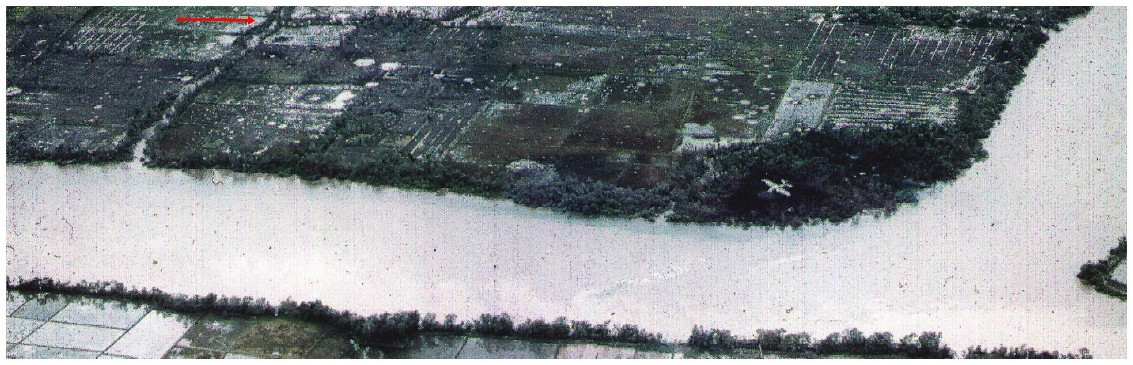

Figure 6. Tree-lined finger stream branching off of the Saigon River, which Captain Baker had ordered Lieutenant Greaves’ platoon to move into, in an attempt to roll up the Viet Cong’s right flank along the lower section of the stream (below the point where a canal branches off to the right of the stream).

Delta Company
Delta Company was scattered in small groups all over their LZ, where the choppers had dropped them off in an attempt to avoid the enemy’s concentrated gunfire on their lift formation. As small groups of soldiers tried to escape the enemy gunfire and regroup, well-trained VC snipers immediately shot them. As mentioned earlier, some of Delta’s casualties could have been avoided if their less experienced soldiers had not attempted to run along the top of the dikes.

Bob Castillo was one of the Manchus pinned down in a small group. He crawled through the mud to a dike where some other men had gathered and began to return fire. Bob said, "I couldn't tell what everyone was shooting at. I could see a wood line or clump of bushes and trees about a hundred yards across the rice paddy…there was a lot of confusion.”

Fighter jets came in to try to roll back some of the Go Mon positions closest to Delta Company. Buzz Copple recalls seeing a bomb released behind Delta Company and scoring a direct hit on a group of VC: "I saw it hit right in the middle of the [VC] and they just disappeared…vaporized…then I saw pieces of body parts flying away. The jet then began to make strafing runs…this is the only thing that bailed us out."

Lt. Jim Itow was the only Delta platoon leader to gather enough men to make an attack on the enemy positions. The only solid ground between Delta's LZ and the wood line was a single dike running straight toward the middle of a VC bunker line. Lt. Itow used the cover of the dike to take his platoon closer in, hoping to knock out the bunkers that were pinning Delta Company’s men down on the LZ. As Itow’s platoon approached the wood line, they suddenly started receiving gunfire from both flanks and from directly ahead. Bob Castillo said, "They didn't have a chance. They just got cut to pieces."

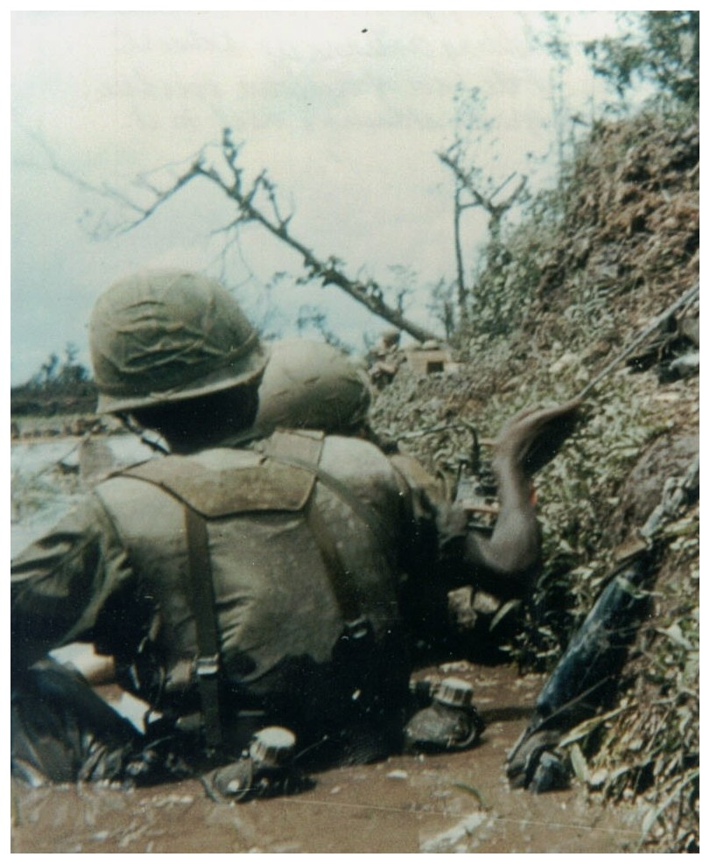

Figure 7. Photograph taken by Keith Bolstad of a Delta Company platoon leader on the radio with his RTO holding the antenna. In the picture, near the base of the leaning tree, is an empty VC bunker built into the embankment with several of our guys standing next to the bunker.

Resupply Runs and Evacuation of the Casualties

A chopper with a re-supply of ammo came in and kicked out ammo boxes into the muddy rice paddy near Delta's position. The Delta Manchus had to fish around in the mud for the crates, with enemy gunfire popping in the water around them. Then someone saw a lone figure stumbling desperately back from where Itow's platoon had made its heroic but fatal attempt at counterattacking. The closest Delta soldiers began laying down suppressing fire for the returning Manchu. It was Lt. Itow returning to get help for his platoon, which had been decimated. Itow was breathing hard, straining for air. Someone gave him a cigarette, and he drew hard on it, and began to talk. He wanted more ammo and volunteers to go help him save what was left of his men. Bob Castillo said, "We couldn't believe it. He was already hit 2 or 3 times. It was suicide to go out there. Lt. Itow grabbed a bunch of bandoliers, put them around his neck, and bolted back over the edge of the berm…[then] all hell broke loose again with automatic weapons fire going both ways." Itow went back alone. After a time, Bob heard cheering and saw Itow coming back with a wounded man. They were both stumbling; he was dragging the wounded soldier most of the way.

The wounded man had been shot twice in the back and was trembling and silently crying when a medic came to his aid. He was told to hold on; a chopper was coming for him. As the chopper approached, an exchange of gunfire erupted again. Doc Hyder was organizing the wounded for evacuation and came over to ask, "Think you can walk?" The wounded soldier nodded yes. He was a big heavy kid. Bob Castillo and Doc Hyder were struggling to carry him, keeping him moving toward the incoming chopper. When Bob was halfway to the chopper, he stepped into a bomb crater in the paddy and went completely underwater. When he surfaced, the wounded soldier was leaning on a dike holding on with both arms. At this point, Doc Hyder collapsed from total exhaustion, shaking badly. The adrenaline had finally run out for both of them. Bob told the wounded soldier if he wanted to get out of here, he would have to go the rest of the way on his own. Bob told him, "That's your chopper man…go get it." The wounded soldier lurched forward over the dike, with his arms extended forward and walking toward the evacuation helicopter in quick jerking movements like Frankenstein. The chopper’s crew reached down, yanked him inside and quickly flew out of the Horseshoe.

Captain Rosenberg asked Lt. Rich Parris to find Itow's platoon. Lt. Parris asked for volunteers for a recovery mission, and more guys volunteered than could be spared. He finally settled on ten volunteers. They crawled through the mud and sniper fire for three hours, trying to recover what was left of Itow's men: 15 to 20 living and dead. Parris and his RTO (Scott Curtis) stayed behind trying to recover as many weapons and as much gear as possible. This was a daunting task as bodies, weapons and gear was scattered across six rice paddy fields, the closest only 50 meters from the wood line. It was nearing the end of the day, and beginning to rain, with fog rolling in and visibility dropping to near zero. The Go Mon took advantage of this and left their bunkers, trying to encircle Delta Company’s rescue party. Some of the fighting was at close quarters.

Al Clinton, Bob Castillo and Keith Bolstad joined another rescue and recovery attempt—crossing paths with Lt. Parris, who was laying wounded out in an open field along with other WIA and KIA’s. Lt. Parris, along with other wounded men, returned to Delta’s perimeter and were evacuated on one of the last dust-offs for the day. The rescue party had managed to recover many of the casualties, but could not recover those closest to the Go Mon bunker line. Several of the Delta Manchu bodies were not recovered until the following morning.

As the sun began to set, Clinton, Castillo, Bolstad and others had crawled down the side of a dike toward Delta’s casualties and began receiving enemy AK-47 and carbine gunfire. About halfway out and unarmed, the guys started spreading out—going after wounded and dead soldiers. Castillo stayed close to the dike and people ahead him were hollering “KIA!” As the dead were recovered, their bodies were slid through the mud to Castillo and pulled over the dike away from the gunfire. Disregarding their own safety, many of the rescuers stood up exposing themselves to the enemy’s gunfire, going after Delta’s casualties. Bolstad recalls being one the farthest men out, recovering as many casualties as he could find or see, “We managed to get back all we could, except [for] some remaining KIA’s closest to the wood line.” He recalls there being two Delta guys who were not found until the next day that might have died of their wounds during the night. At 1810 hours, Delta reported: 11 WIA and 1 KIA evacuated; 1 KIA remaining in its perimeter; and 2 other KIA accounted for, but still needing to be brought in. At 1845 hours, another 4 WIA and the 1 KIA were evacuated, with 4 KIA (instead of 2) still outside of Delta’s perimeter.

Unfortunately, not all of the Manchu’s evacuated casualties were from enemy fire. A Delta soldier with a sucking chest wound was finally evacuated at 2035 hours on the last dust off of the day. At 1850 hours, one of Delta’s squads had been walking along a dike and the squad leader’s weapon accidentally discharged wounding this soldier who was in front of him.

During another chaotic attempt to get the wounded out, a bizarre sight appeared in the distance. A Cambarra jet with a gunship flying alongside of its right wing was heading straight for Bravo Company’s perimeter, with a Black Widow Medevac (medical evacuation helicopter) underneath. The Cambarra jet with its 20mm cannon and the gunship with its 7.62mm mini-guns began firing into the woods forward of Bravo Company's position. The Medevac swooped down under the gunfire and extracted as many wounded men as it could get, taking numerous hits before making it out safely. By then, Delta Company had set up a resupply and Medevac perimeter to the rear of Bravo Company. The 1st Brigade’s Daily Staff Journal or Duty Officer’s Log, contains the following entry, “At 1649, D 4/9 resupply ship dusted off 2 D 4/9 WIA and 2 WIA from B 4/9.”

Back in Cu Chi, Lt. Fritz Wiese (our Battalion S-4 Support Officer and a former Alpha Company 2nd Platoon Leader) approached the crew of five Black Widow slicks parked at the airfield’s east re-supply area and requested two ships for a strictly voluntary tactical emergency (TAC-E) supply mission. He told them that the Manchus were pinned down and running out of ammunition, and facing the possibility that the Go Mon might try a frontal attack or try to overrun their positions during the night. The flight crew of Black Widow chopper #16205 and Black Widow #16222 gallantly volunteered. Black Widow #16205 (WO Charlie Mauer and an unknown pilot) went to the aid of Delta Company and Black Widow #16222 (WO J.J. Spearman and Mark O. Hayes) to the aid of Alpha Company.

Lt. Wiese was not aboard either of these TAC-E flights, but he was seen aboard one of the other (very few) re-supply ammo runs that were made that day. He (with his big handlebar mustache and a huge 6’4” frame) was seen kicking out ammo boxes from a hovering helicopter. Some of which nearly hit the men below. During this ammo run, he was slightly wounded by a ricocheting bullet, which struck his wristwatch and lodged in the flap of skin between his index finger and thumb.

Earlier during Bravo’s LZ insertion, Mark Hayes’ chopper had taken a hit from an armor piercing bullet that cut both oil lines—draining the oil from the engine and causing the chopper to leave a smoke trail from an overheated engine all the way back to Cu Chi. Upon arriving at Cu Chi, Hayes’ helicopter was disabled and could not be flown again. Another chopper flown by WO Chuck Restivo had sustained one hit, but was still operational. Restivo had been wounded, so pilots were needed to fly it. Hayes (Black Widow 14) and his aircraft commander (WO J.J. Spearman, Black Widow 23) took command of Restivo’s chopper, along with its door gunners William Sondey and Alfred J. "Smitty" Smith. This chopper crew brought in a supply of ammo and took out seven wounded Alpha Manchus, displaying bravery under intense fire and saving many lives. Sondey was wounded and Smitty was killed while on this TAC-E supply and evacuation mission.

Lt. Beedy also displayed a great heroic effort, over and above what was expected, in retrieving Alpha’s dead and wounded. He organized the gathering of casualties from all over the LZ, putting them in a central location. Beedy himself brought some of these men to the PZ for evacuation. In addition, if it had not been for the chopper crews that were brave enough to fly into the heavy enemy gunfire, many more Manchus would have died. Many survived because of their sacrifice and bravery. The following entry was logged in the 1st Brigade’s Daily Staff Journal or Duty Officer’s Log, “At 1415, [Alpha] 4/9 had dust off complete for 10 WIA.”

Willie Gin and his group were pulling out of the tree line when the emergency ammo drop came in. Willie observed the scene of the desperate re-supply run; watching through the tree branches and undergrowth. The slick approached Alpha’s LZ from the south (making a hard 180° left-peddle turn, turning the slick’s nose into the wind, slipping past the Northeast corner of the tree line) and the pilot was struggling to maneuver it into position. There were small groups of Alpha Company’s men struggling through knee-high water toward the chopper. They were crouched down, eyes covered to protect them from the blinding swirl of muddy water and debris stirred-up by the pounding rotor blades of the hovering chopper. Willie could see ammo boxes being kicked out. There was a desperate rush to put as many casualties on board as possible. Alpha Company expended their last remaining clips of ammunition; some soldiers had less than 20 rounds left to cover the chopper. Jack Connell's M16 exploded or was hit by an AK47 round during this barrage and was disabled. Bill Fitch threw him Morgan's M16 so he could keep firing. The VC had managed to wound both door gunners [Sondey and Smith] and to shoot up the chopper almost badly enough to bring it crashing down.

When the slick was about to depart, Captain Lewman requested a second Medevac of three other wounded men stranded in the open rice paddies. The slick lifted off the ground, spinning its nose around toward the north; to pick up the other wounded men less than 200 feet away. While still under fire getting there, one of the wounded door gunners [Smith] was hit a second time. Loaded to capacity, the slick was barely able to lift off the ground with the additional load of wounded on board—having to pull the slick to maximum power into a circling takeoff.

Captain Baker saw this heroic effort from his men's position. He said, "…The slick was shattered by small arms fire. I swear there was no Plexiglas left in the Huey. Either the door gunner, or its crew chief, was killed [Alfred J. Smith] and one other was wounded [William Sondey]. Somehow this shot up Huey bounced around and managed to take off. As the Huey cleared the "Z", one of the pilots radioed back to Captain Lewman to get some more men ready. He would change helicopters, get some new crew, and be back. In my three and one half years in Vietnam, I never saw a more gallant act. I watched with tears in my eyes."

An End to the Day’s Battle

Command and Control from Above
There were several layers of Command and Control helicopters circling above the Horseshoe as the battle raged below. Radio traffic was heavy and getting on the net was difficult for the ground commanders. There were now officers from 25th Division Command, COMAS-MACV, Brigade and Battalion Command flying over the battle zone.

Captain Baker had taken his finger stream objective and he asked for Battalion Command’s permission to continue his counterattack in another direction—to work both sides of the canal that extended north and then turn west toward Alpha’s sector—to cut off the VC and trap them between Alpha’s sector and Bravo’s. Lt. Colonel Stanley Converse (the Battalion’s Commander) called a halt to this plan and permission was denied. This decision might have made sense, that there were company sectors and Bravo Company would have been moving into Alpha’s. But this unwillingness to inflict casualties on the enemy—just when the opportunity arose—is one of the greatest controversies of the Horseshoe. Perhaps all the commanders flying over the Horseshoe had been so shocked and dismayed at what they had dropped the Manchus into, they feared more casualties. However, the Manchu Company Commanders on the ground felt otherwise; that Battalion or Divisional Command had failed the Manchus by not giving them the go ahead to destroy the enemy, after they had fought so hard and paid such a high price for fighting their way out of the Go Mon Battalion’s massive ambush.

Bravo Company did not find more enemy positions to east of them and Captain Baker gathered up his entire Company into the western sector of the finger stream, staying there until almost dark. By then the fighting was over and the C & C choppers left the area and Captain Baker was put in command of organizing the entire Battalion. Much to the Manchus’ dismay, they would not be air lifted out of the Horseshoe, but were left to spend the night out in the water filled rice paddies, with no re-supply of ammunition, rations or fresh water.

Nightfall
Bravo moved out of its location to join up with Alpha Company and found Delta Company to the southwest of Bravo. Alpha, Bravo and Delta Company linked-up and Captain Baker pulled everyone into a perimeter, waiting for the arrival of the 2nd Battalion 27th Infantry (the Wolfhounds) who were being sent out to reinforce the Manchus.

By then the Go Mon knew the battle was over. Air strikes could still be called in and our artillery was on standby. The Go Mon slipped away in the night (taking their dead and wounded with them), probably using their tunnel complexes and the numerous canals, streams and the Saigon River as escape routes. The Manchus were not sure whether any snipers had stayed behind, so the darkness did not give them any rest or comfort.

It was raining and getting colder as the wind came up. Many of the Manchus slipped down into the rice paddy water because it was safer and warmer than sitting on a dike shivering in the rain and wind. Parachute illumination flares were dropped all night long—lighting up the night sky, casting eerie shadows and flickering light across open fields and the surface of the water—just enough so you could see what seemed like thousands of leeches swarming around. The leeches looked like small snakes trying to slither into openings in your clothing.

At 2240 hours, five companies of the 2nd Battalion 27th Infantry “Wolfhounds” (Bravo, Charlie, Delta, Echo and HHC) were positioned on the other side of Saigon River while Alpha Company of the 2/27th was crossing the river aboard gunboats, moving south downriver to the mouth of a finger stream running east-to-west. By 0300 hours, most of the Wolfhounds’ six combat companies had crossed the Saigon River and had linked up with an element of the Manchus’ NOP (night operating position).

Daylight
At the first hour of daylight, everyone was stripping naked to begin the painful process of pulling, burning and scraping leeches off each other, a process which left bleeding wounds and sores.

That same morning (August 31st), the 25th Division’s 1st Brigade S3 Officer (Major Sage) flew over the area in an OH-23 Raven light observation helicopter, dropping a map overlay wrapped around a rock. The overlay contained orders instructing Captain Baker to go east, to pursue and hunt down the Go Mon. At approximately 1000 hours, Alpha and Bravo started its move toward OBJ-2 in the vicinity of map coordinate XT739193. No enemy contact of any significance was made that day; except for one Bravo WIA from a gunshot wound and the dust-off of one Delta casualty at 1330 hours. That evening the Manchus spent the night along the banks of the Saigon River, learning a lesson the hard way—that the Saigon River is a tidal river, after it flooded their positions.

After two exhausting days, no enemy contact was made and the Manchus were finally extracted from the area: Alpha Company returning to Camp Martha, Bravo Company to Camp Juanita and Delta Company back to the 25th Division’s base camp in Cu Chi.

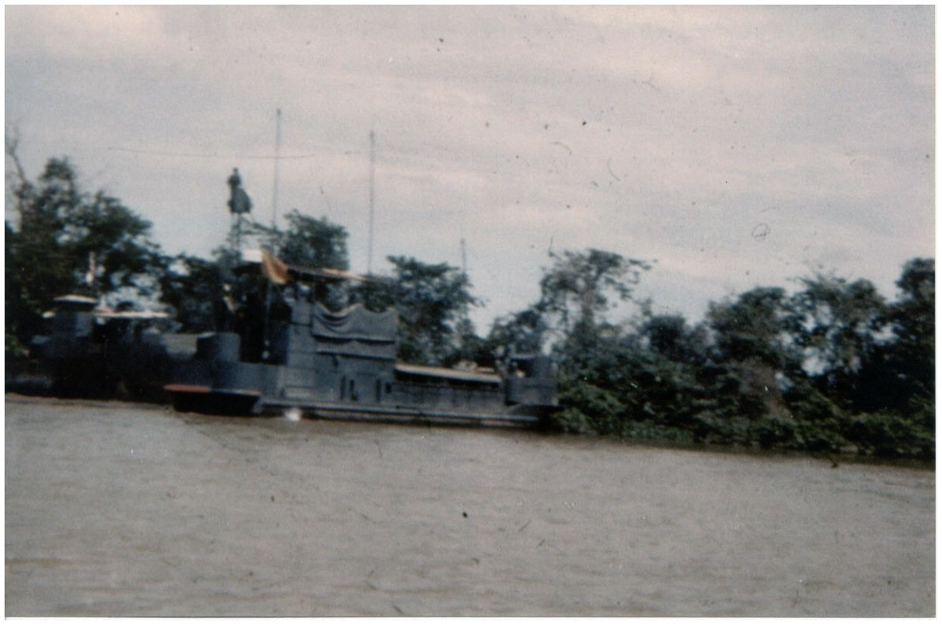

Figure 8. Photograph taken by Keith Bolstad. Pictured are two of the gunboats used to extract Delta Company’s men from the Horseshoe. Alpha and Bravo Company were air lifted back to Cu Chi by helicopters.

Retrospective Thoughts
In retrospect, there were no victors at the Battle at the Horseshoe. The Manchus may have accomplished a tactical victory by temporarily driving the Go Mon Battalion from one of their major bases, but they had many more yet to be found. The Go Mon was far from being destroyed; they would appear again during the 1968 TET Offensive and would participate in the attack on Saigon. During the TET Offensive, the Manchus would be sent down from Tay Ninh to hunt them down again, after being pulled from fierce fighting with the NVA [North Vietnamese Army] near the Cambodian border.

The Go Mon probably suffered as many, if not more, casualties as the Manchus on August 30, 1967 at the Battle at the Horseshoe. As the first rays of daylight broke, there were no victors on either side, only survivors.

Manchus Remembered

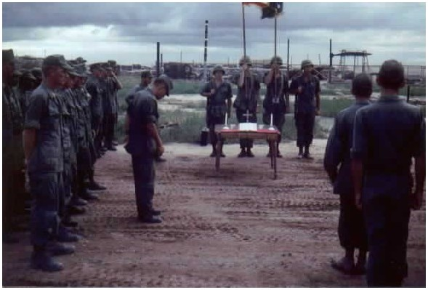

Figure 9. Manchu memorial ceremony held in honor of those Manchus killed in action on August 30, 1967, at the Battle of the Horseshoe. Photograph taken by Bernie Czerwinki.

Manchu KIA Casualties:
• PFC Tom J. Bagenstose (Age 20), Delta • PFC Terrence J. Kudro (Age 19), Delta
• PFC Douglas Coats (Age 19), Delta • PFC Robert W. Morgan (Age 20), Alpha
• SP4 Benjamin D. Coy, Jr. (Age 21), Delta • SP4 Vaughn S. Morgan (Age 23), Alpha
• SP4 Dennis E. Gabbert (Age 20), Alpha • PFC John J. Pinder (Age 19), Delta
• PVT Roy H. Leach (Age 19), Delta • SFC Charles Wilkerson (Age 31), Alpha

Total Number of Manchus Wounded in Action: 36 (Alpha 12, Bravo 4 and Delta 20)

Assault Helicopter Company [AHC] KIA Casualties:
• 188th Black Widows KIA: CPL Alfred J. Smith (Age 26)

Total Number of AHC Wounded in Action: 9 (Black Widows 5 and Black Hawks 4)

